SD6501 – Mobile Application Development​
Assessment 2 – Group Project Documentation​
Project Title:​ Campus Attendance System
Group Name:​ Team T1
Course:​ SD6501 Mobile Application Development
Semester:​ Semester 1, 2026

I. Project Purpose
This project is a cross-platform mobile app built with .NET MAUI. It is used for campus check-ins and location tracking.
The app lets students log in, get their current GPS location, save check-in records, and view history on the home page.
It solves problems with old paper sign-ins, which are slow, can't verify location, and are hard to keep. This app makes check-ins digital, traceable, and able to track locations.

II.Project Requirements
1.Based on the prototype from Assignment 1, finish a working .NET MAUI app.
2.Use the device's native GPS​ to get latitude and longitude and use it correctly.
3.Use data binding and save the check-in records to the local file system.
4.Use GitHub​ to manage code and add the teacher as a collaborator.
5.Use debugging and testing to make sure the features are stable.
6.The interface should be good for touch screens and provide clear navigation.

III. Requirement Solutions
1.Framework & Platform: Use .NET MAUI​ so one set of code works on Android and Windows.
2.User Login: Check the username and password. If correct, go to the main page to control access.
3.GPS Location: Use MAUI’s built-in tools to get real latitude and longitude for verification.
4.Data Binding & Storage: Use data binding to show history. Save records as JSON​ files locally.
5.Page Navigation: Use AppShell​ to switch stably between the home page and the GPS page.
6.Version Control: Use Git/GitHub​ to manage code. Commits are clear, and the teacher is added as a collaborator.
7.Debugging & Testing: Use Visual Studio breakpoints to test the whole process: login, location, saving, reading, and display.

IV. Interface Description and Screenshots
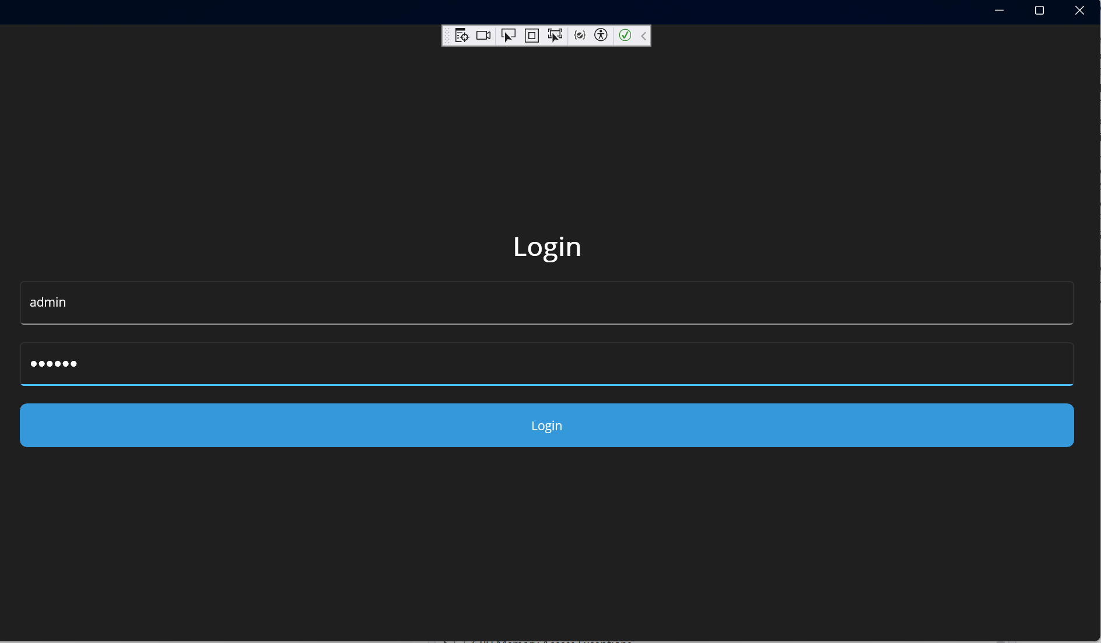

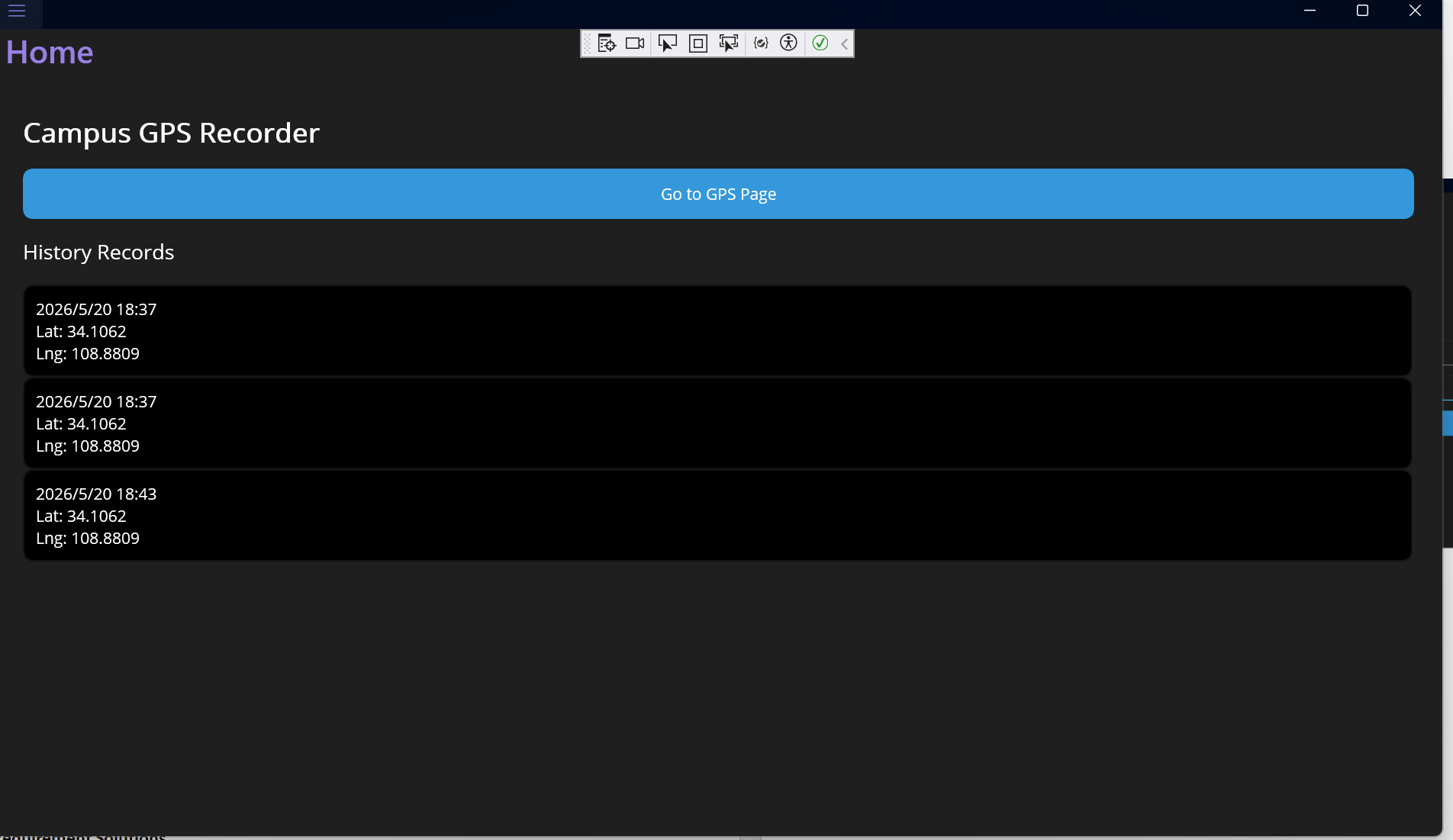
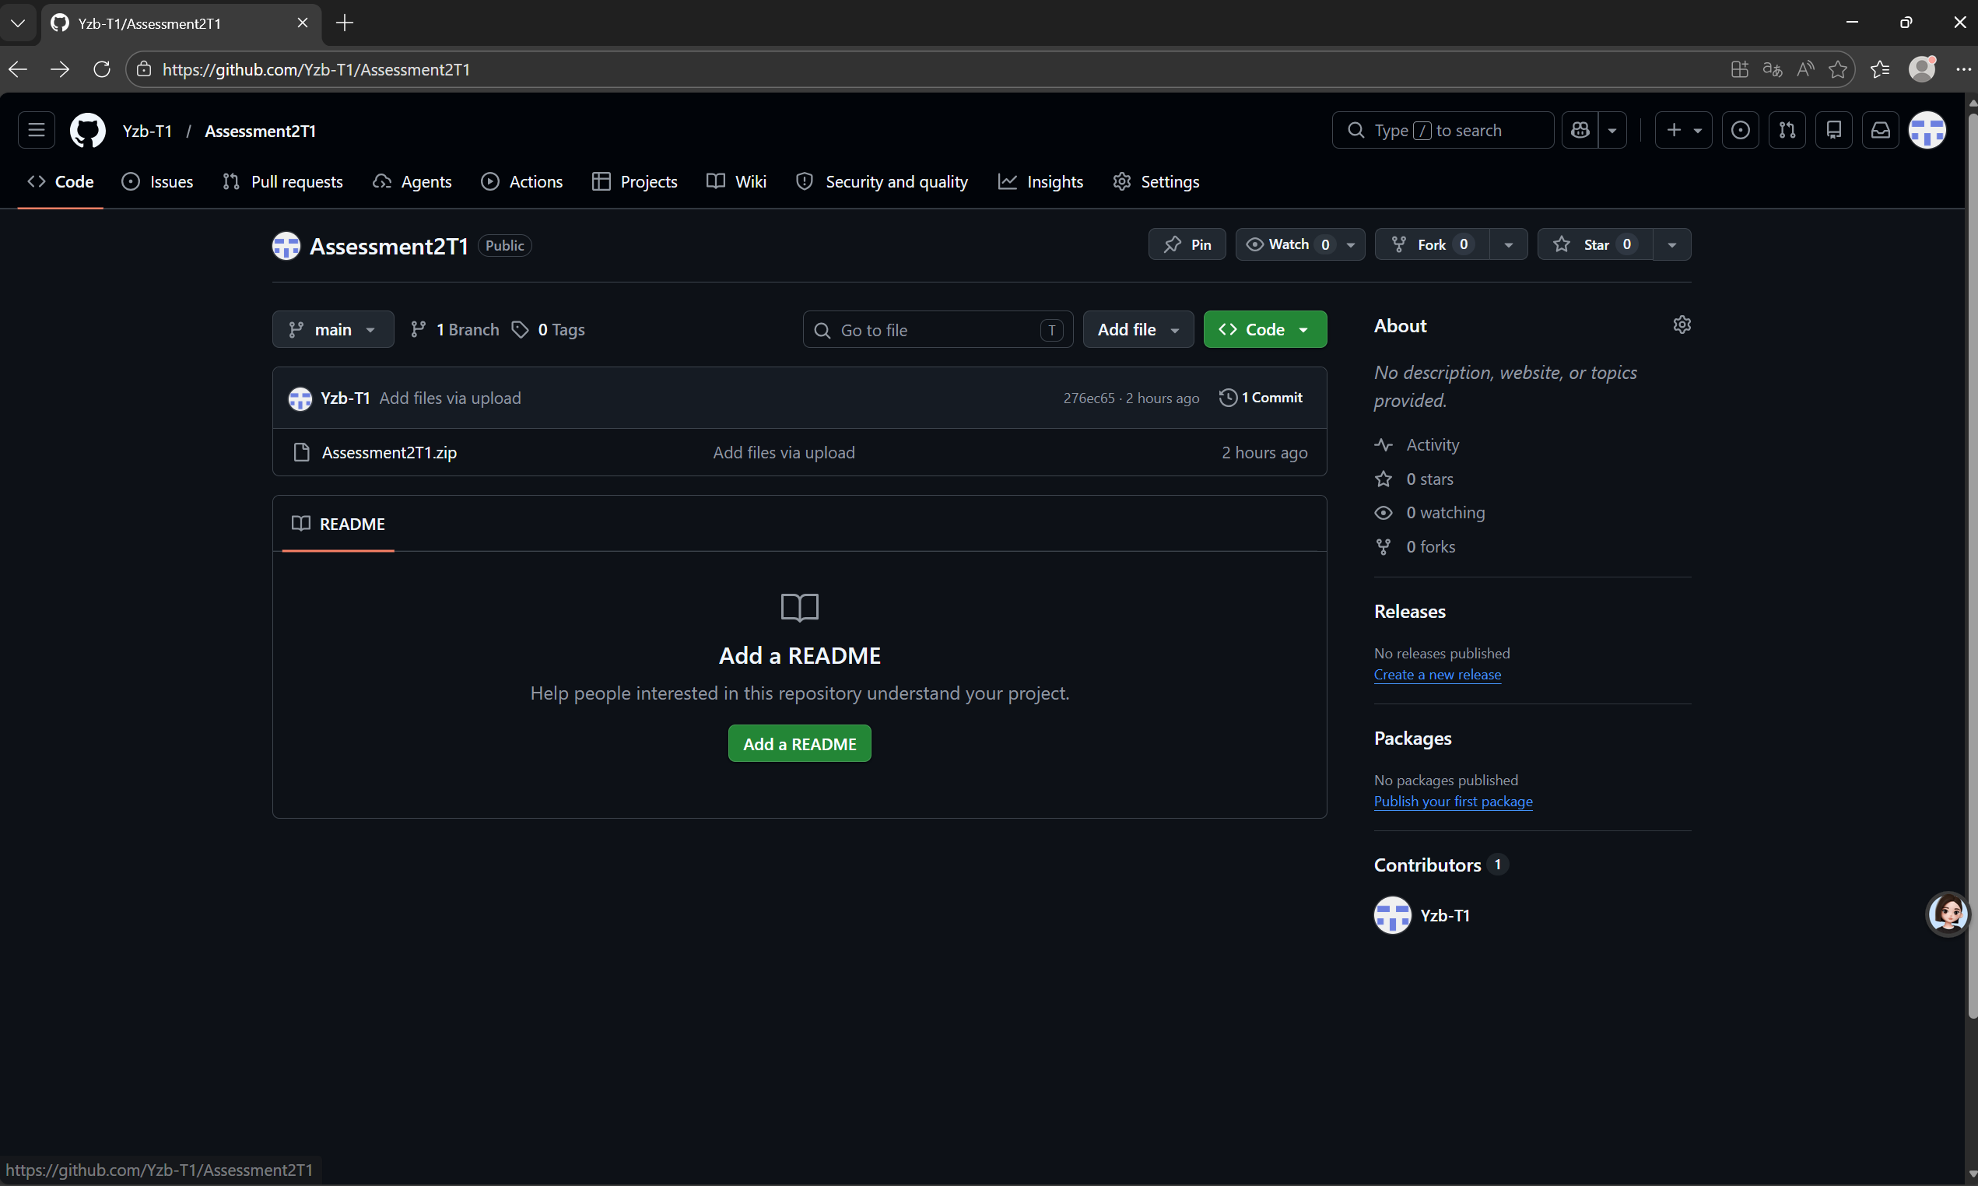
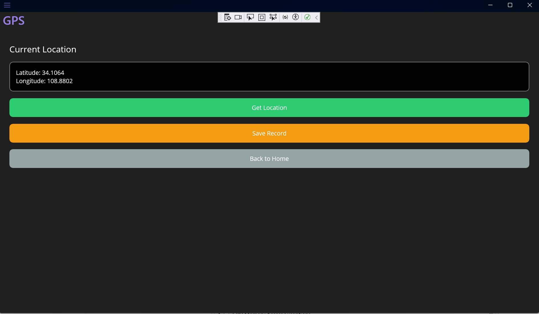
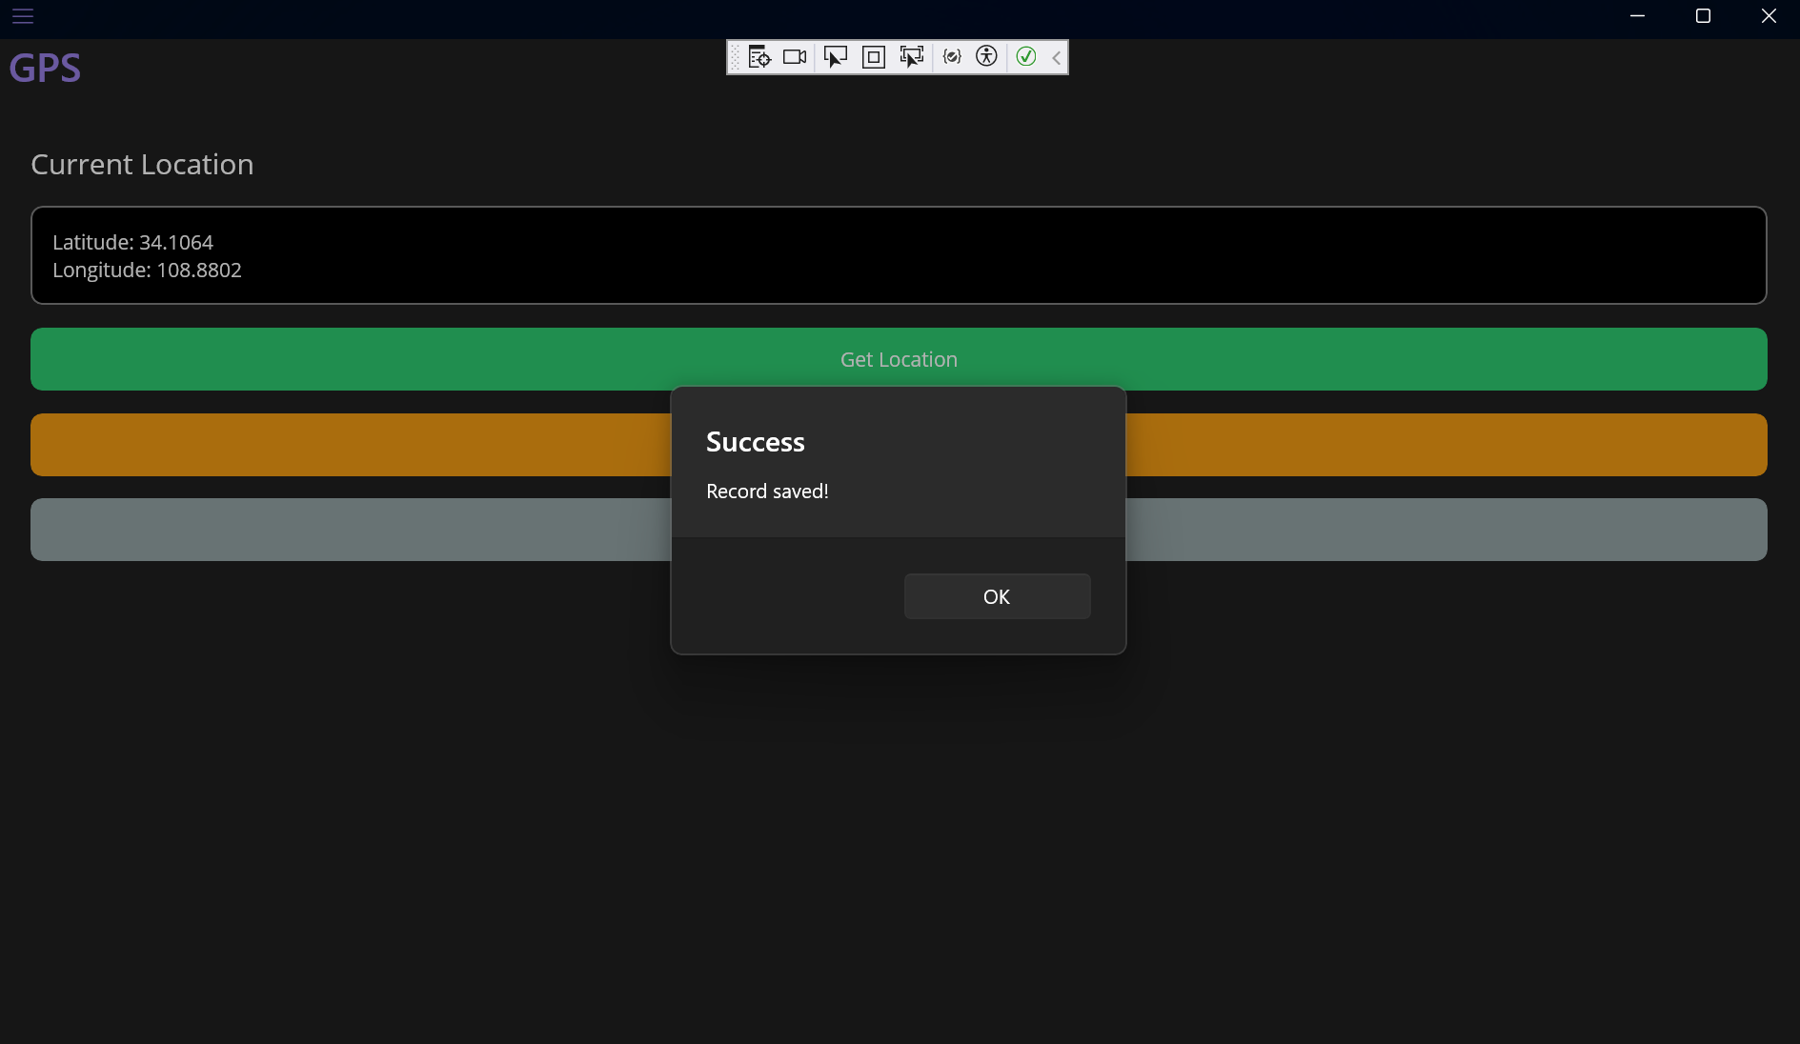
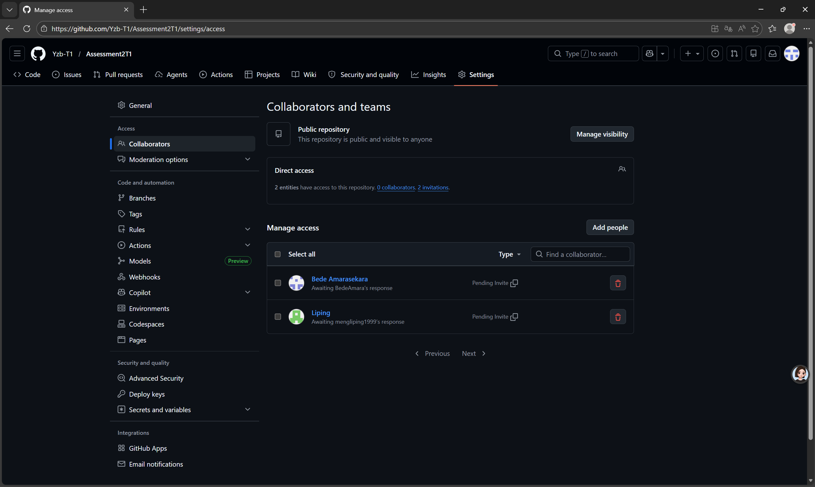

V.Differences from Prototype
1.We mostly kept the design from Assignment 1, but made these reasonable changes:
2.Changed fake GPS to real device GPS. This is better for real use.
3.Added local storage to save and view history (Assignment 1 didn't have this).
4.Added login verification to make the app safer.
5.Improved the layout and colors to make the UI look better and easier to use.
6.Reason for changes:
7.To turn the "prototype" into a real working app that meets the requirements for Assignment 2.

VI. Challenges and Solutions
1.Problem:​ Could not get location due to permission issues.
2.Fix:​ Checked and configured MAUI permissions to ensure the code could call the GPS.
3.Problem:​ The home page did not refresh after saving data.
4.Fix:​ Rewrote the OnAppearingmethod to reload records automatically every time we returned to the home page.
5.Problem:​ The list would not show up with data binding.
6.Fix:​ Used OnPropertyChangedto notify the UI to refresh, ensuring the binding worked.
7.Problem:​ Navigation using AppShell failed.
8.Fix:​ Unified the page route names and set the ShellContentroutes correctly.
9.Problem:​ Could not enter the main interface after logging in.
10.Fix:​ Modified the app startup logic to load AppShell only after successful login.

VII. Unresolved Issues
All features are working well. There are no unresolved problems:
User login works fine.
GPS location is accurate.
Check-in records can be saved and read.
Data binding displays correctly.
Page navigation is smooth.
Local storage is stable.
Debugging and testing are complete.

VIII.Function Summary
Touch UI:​ Buttons are big, spacing is good, and navigation is clear.
Native GPS:​ Gets and shows latitude/longitude for check-in.
Data Binding & Storage:​ Binds history list and saves to JSON files.
GitHub:​ Created repo, committed code, and added teacher as collaborator.
Debugging:​ Used VS breakpoints and tested the whole process.
MAUI Solution:​ Can be demonstrated, compiled, and run in VS.

IX. Group Division of Labor

Member 1:​ Login page and project structure setup.
Member 2:​ GPS function and permission configuration.
Member 3:​ Local storage service and data models.
Member 4:​ Home page, data binding, and UI display.Documentation, GitHub management, and presentation

